Installing File:

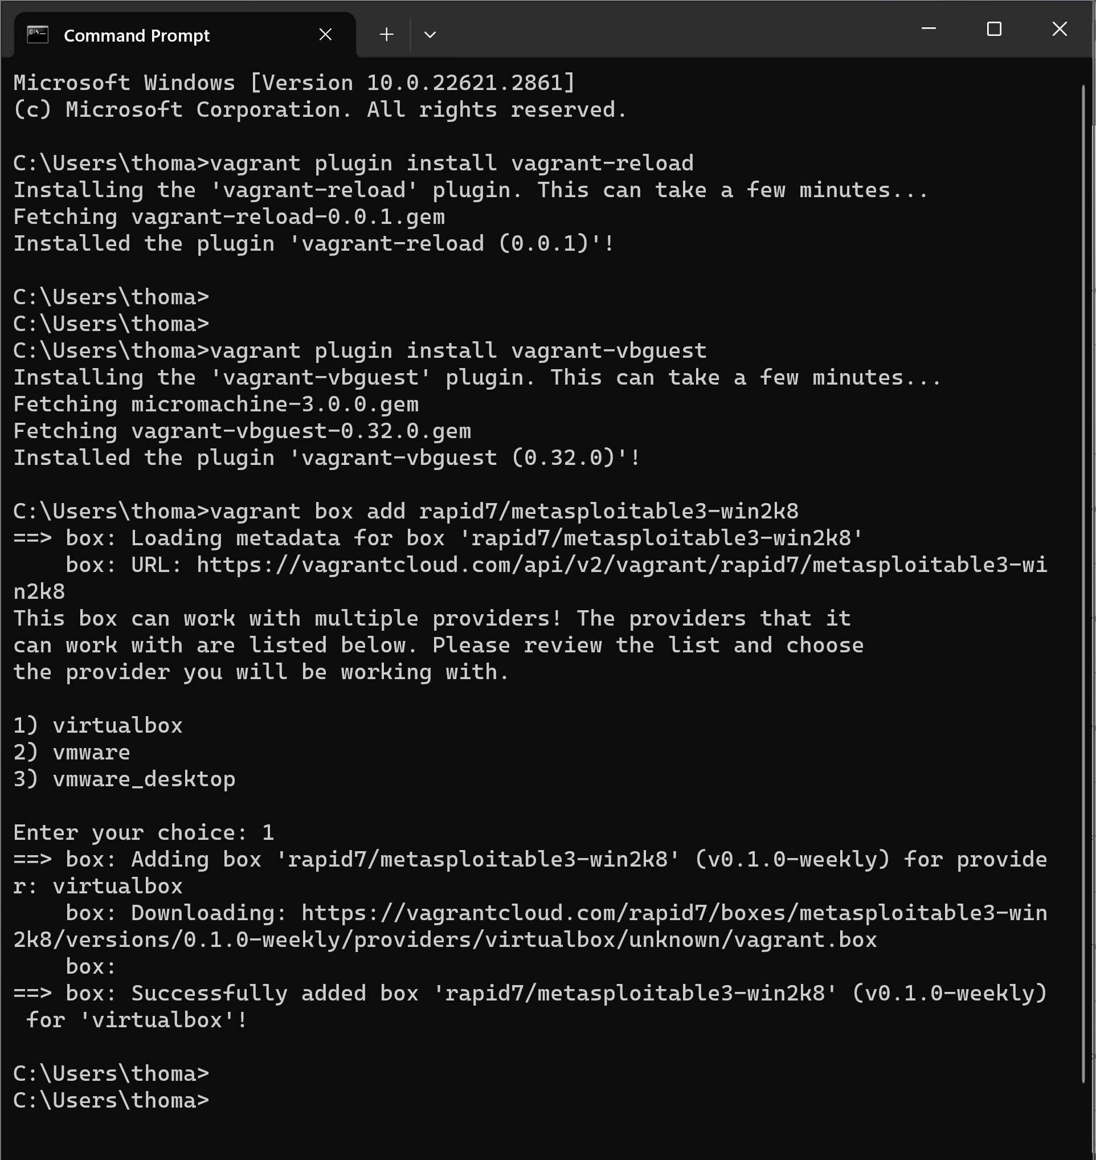

Renaming file:

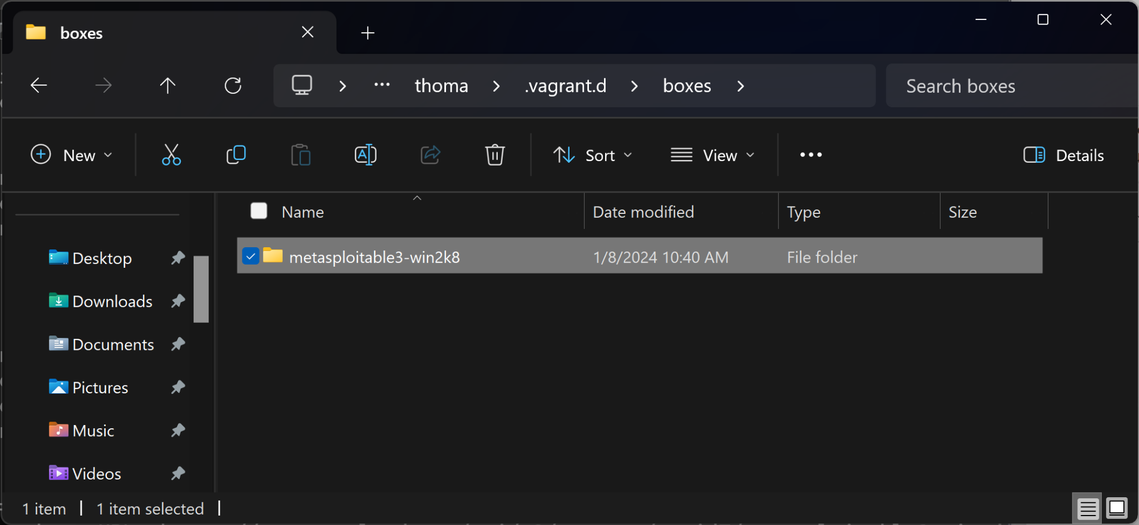

Start-Up the new Virtual Box:

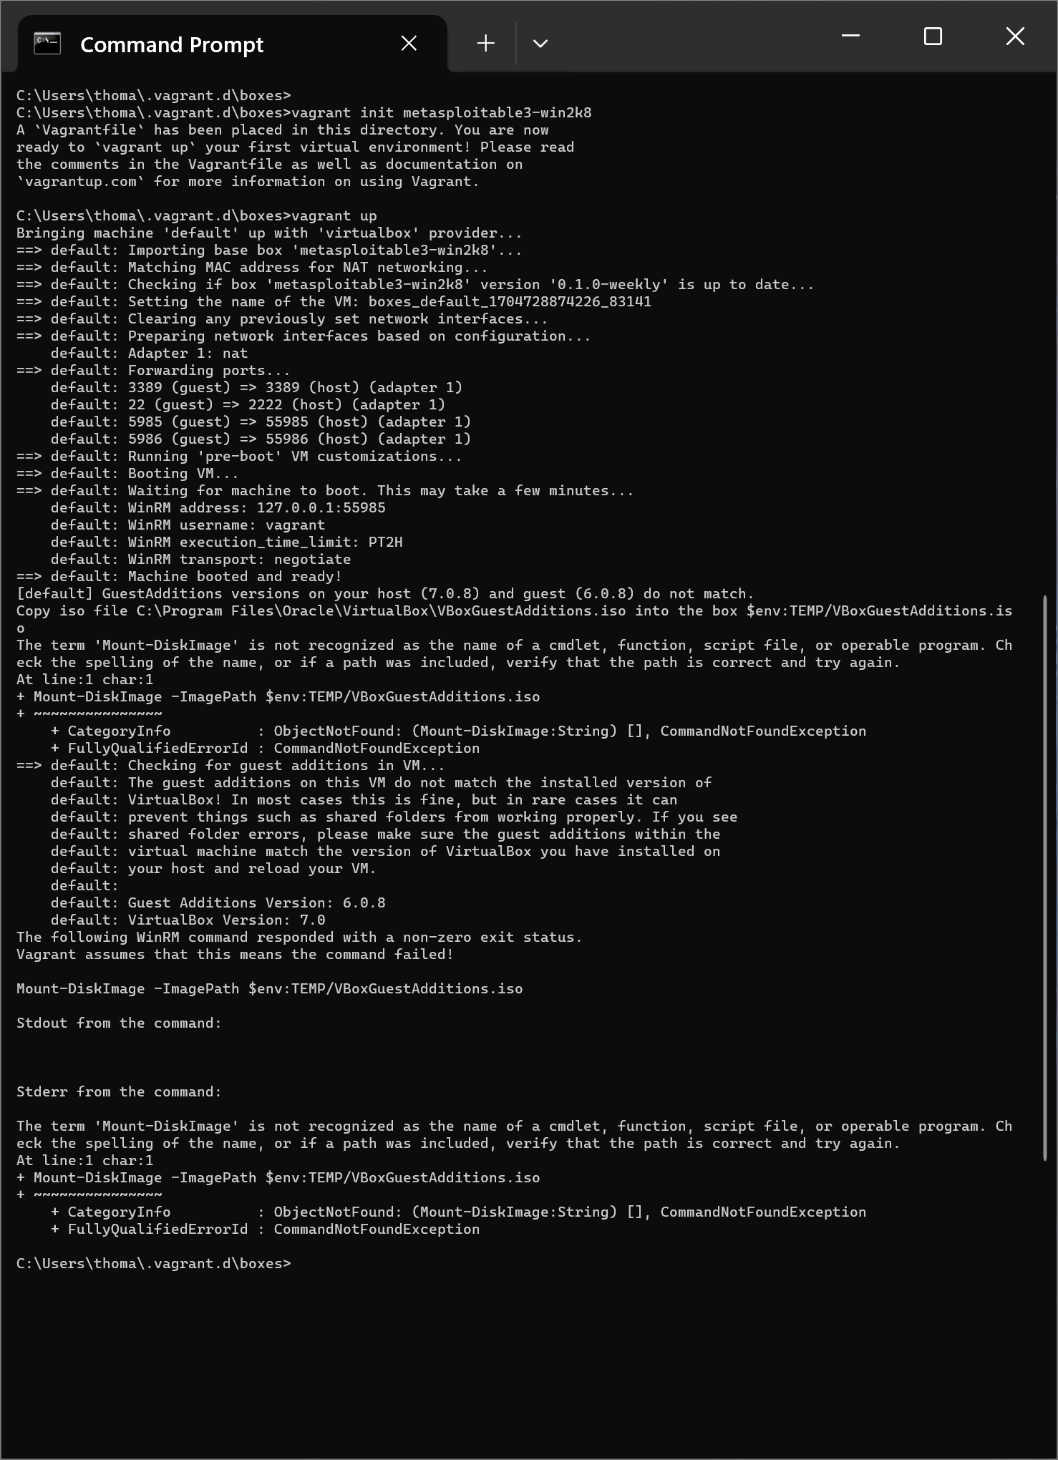

Device Renamed:

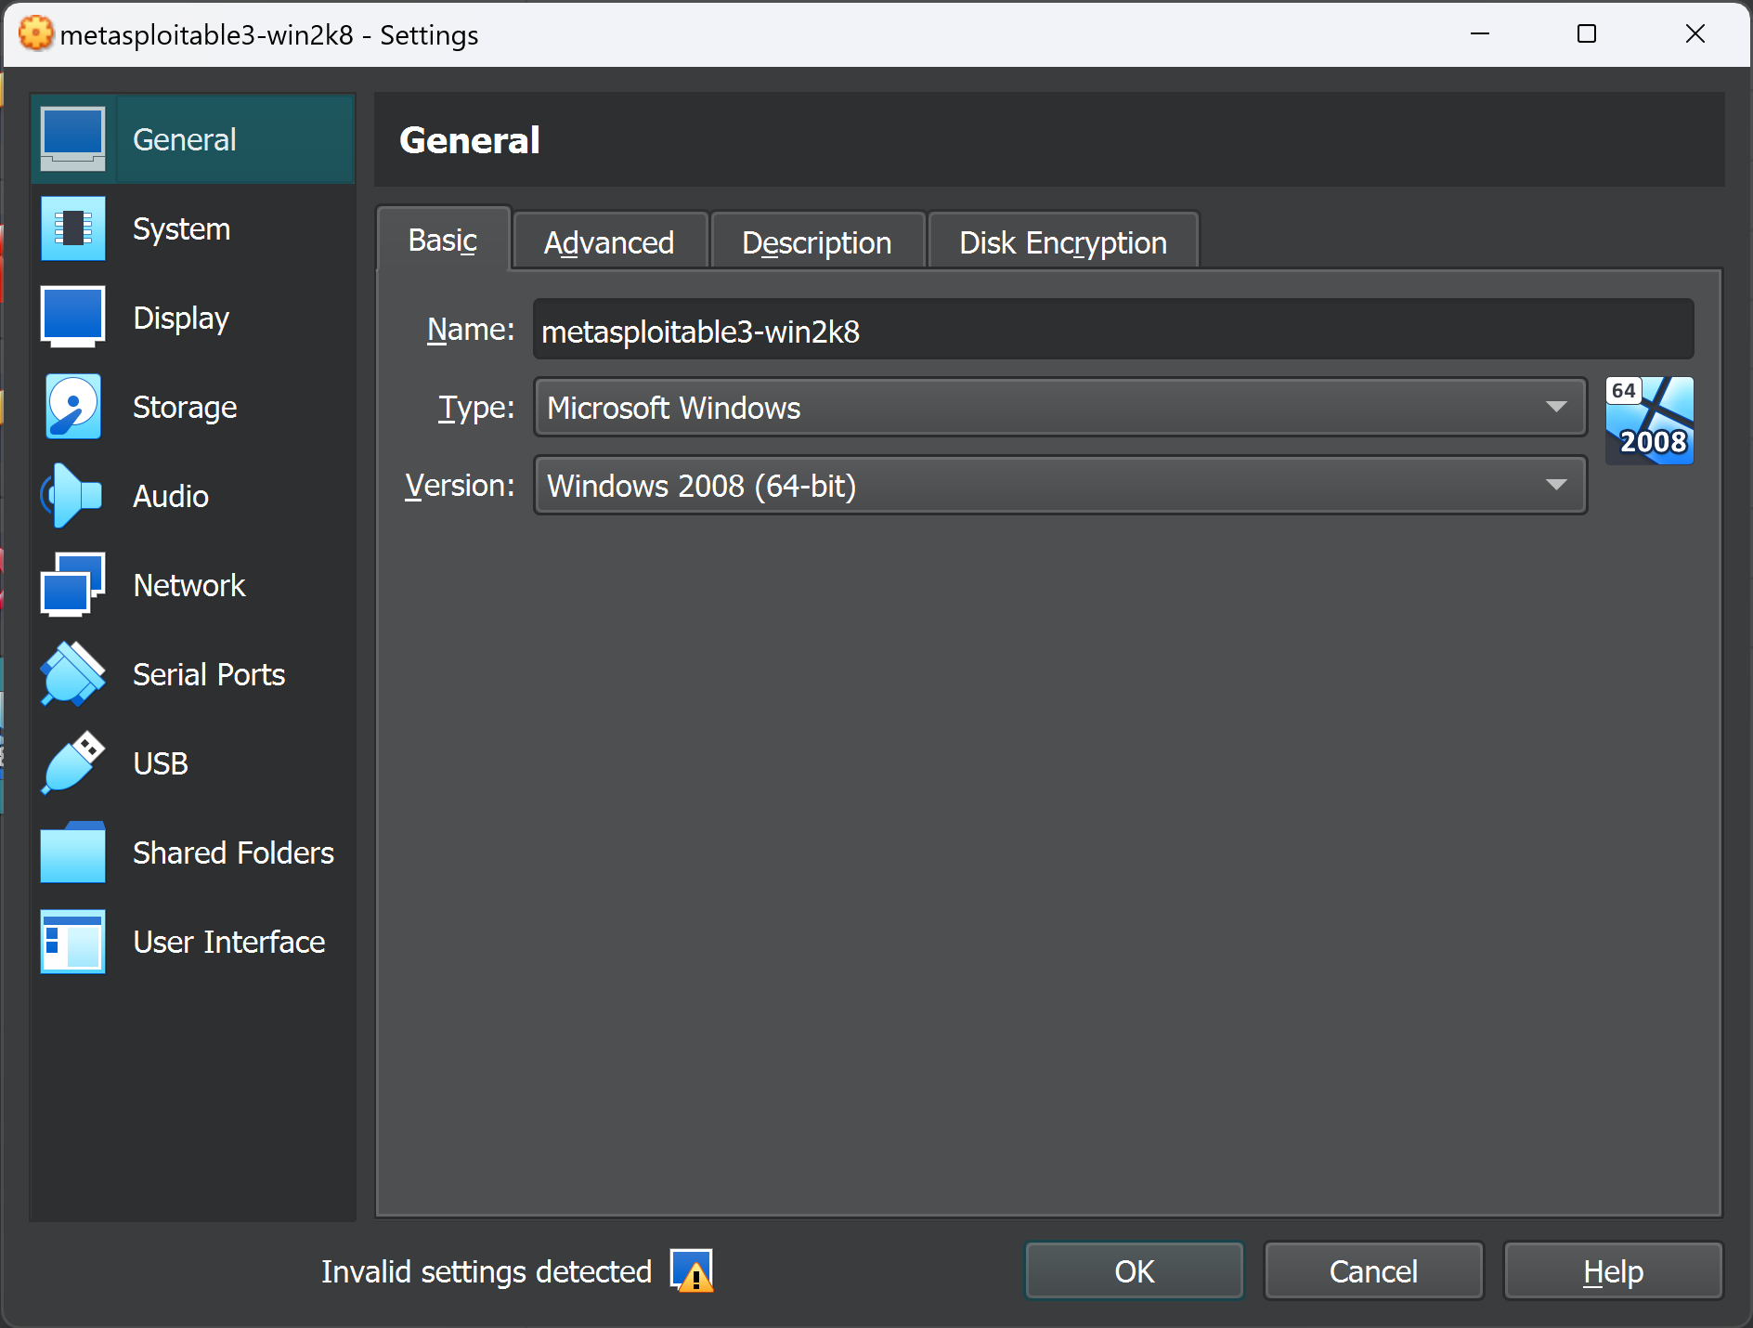

Network Settings Applied:

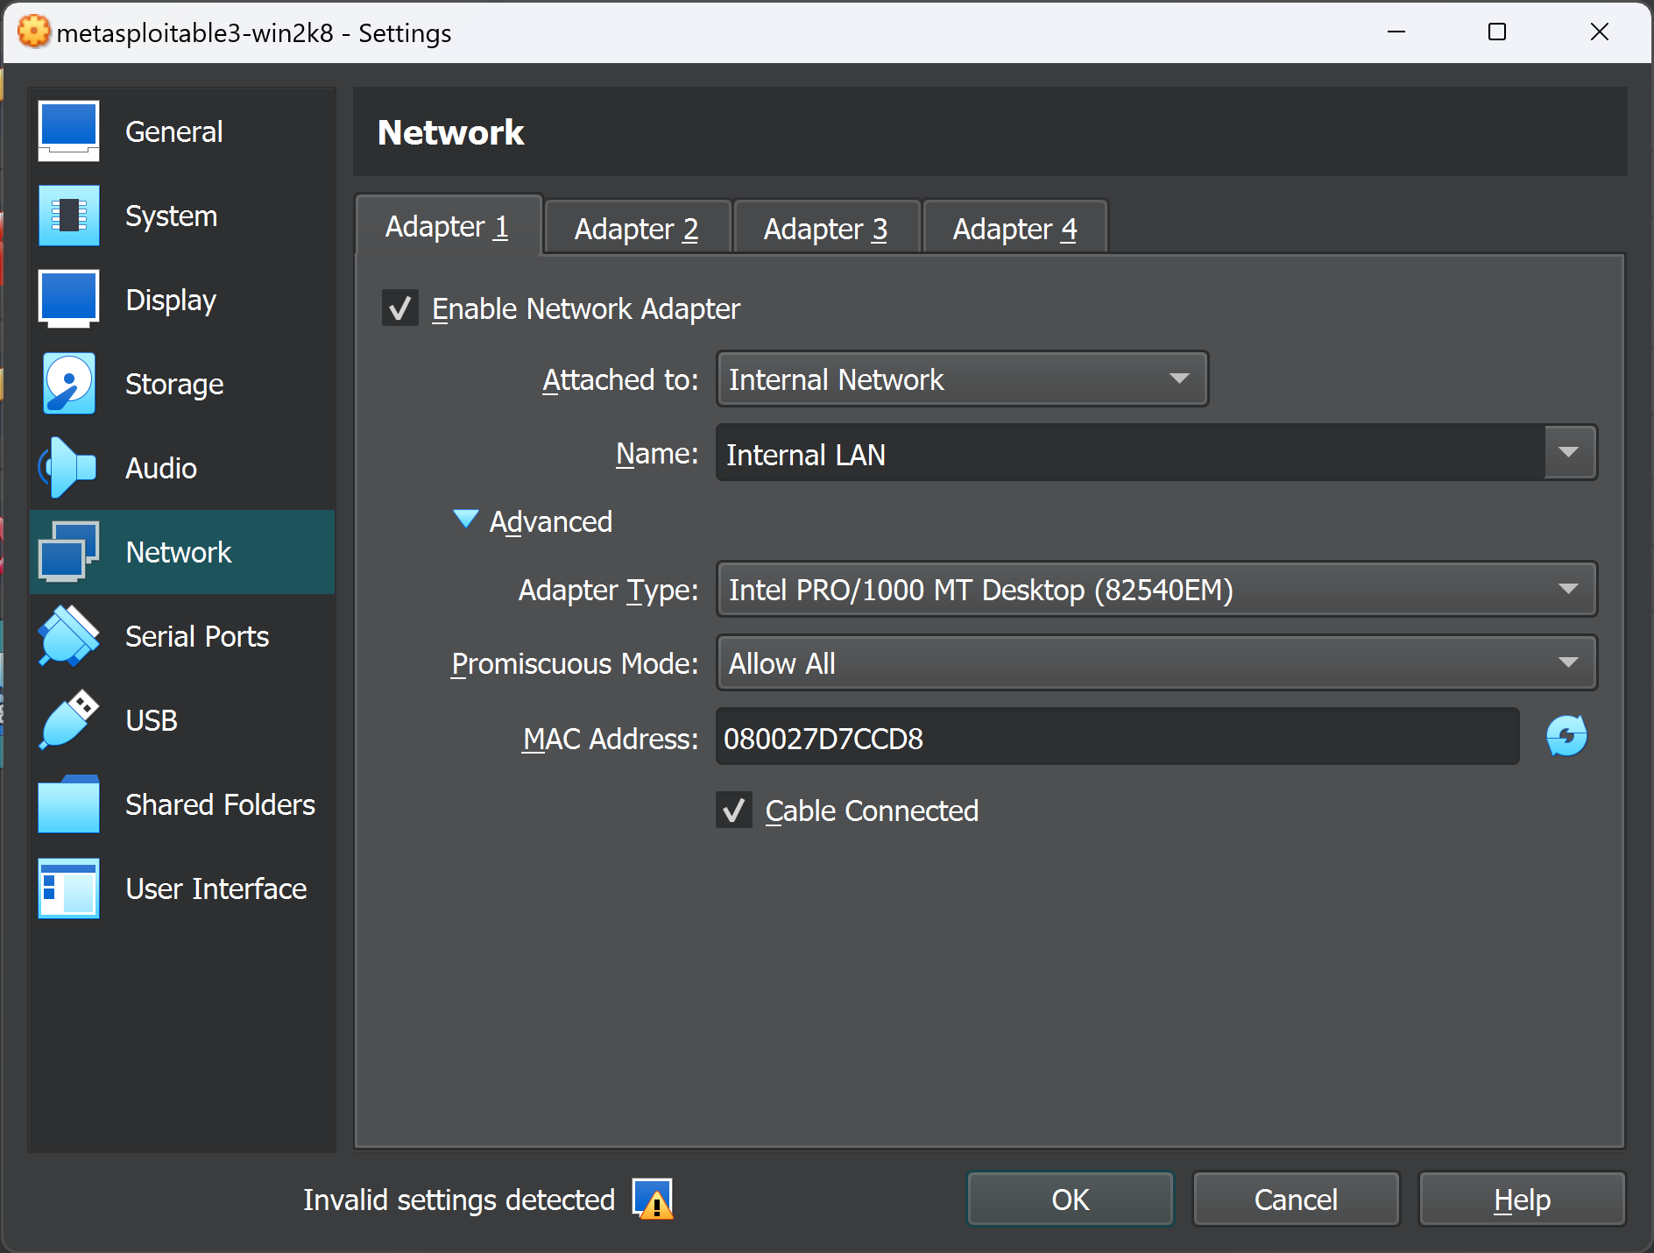

Shows up on Kali and IP address confirmed by the metasploitable device:

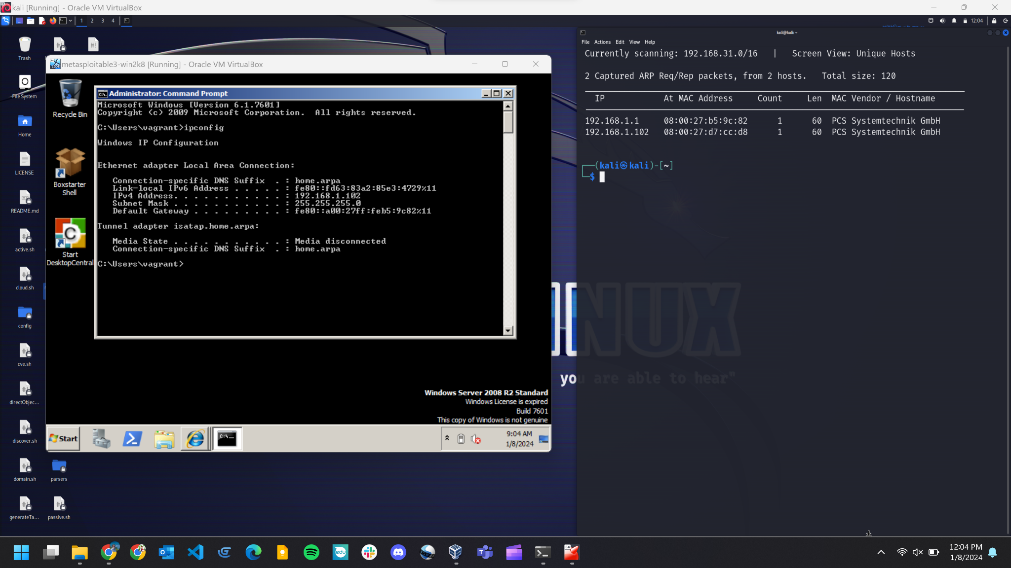

IP Address of Metasploitable3: 192.168.1.102